Gordon Graham Memorial Plaza
Hendricks County Airport (2R2)
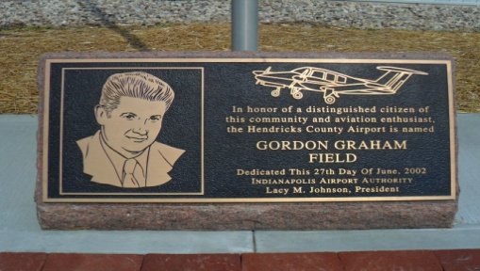
The Hendricks County Airport is named for Mr. Gordon Graham, a local broadcast figure and general aviation enthusiast. The general aviation community is a small but very close knit group of individuals and families that share their love of aviation with everyone they meet. Mr. Graham was the epitome of this effort to share the freedom of flight with those he met. The Hendricks County Aviation Association (HCAA) wishes to honor all general aviation enthusiasts past and present. You can honor the aviator in your life with a memorial brick to commemorate their love of aviation and place their brick with those of other aviators in central Indiana.
Each brick is $50 and all checks should be made payable to HCAA. The inscription on the brick is limited to 3 lines of 13 characters each (each space between words is counted as a character). All inscriptions will be centered on the brick. Please print clearly. Please leave contact information at the bottom of this form if someone needs to call for questions.

If you wish to mail your check, please send it to the attention of HCAA President, Ron Drake, 8239 Captain Drive, Avon, IN 46123.
Thank you for your support of general aviation in central Indiana.
Name:________________________________________________________________________
Contact Number:________________________________________________________________
Email address:__________________________________________________________________

