Please join the Hendricks County Aviation Association at the annual Christmas Party
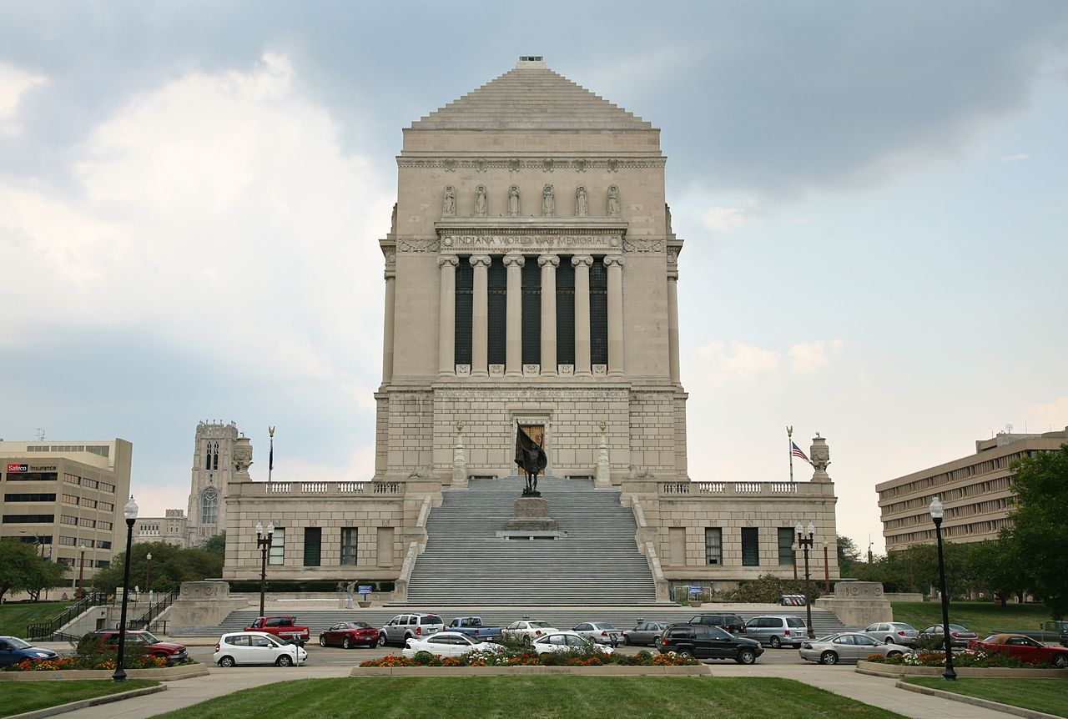
Date: Friday, December 5, 2014
Times: 5:00pm- 6:3pm Museum Tours/Cash Bar 6:30pm Dinner
Location: Indiana War Memorial 51 East Michigan St. Indianapolis
Buffet Menu: Herb Roasted Chicken, Braised Beef Short Ribs, Mixed Green Salad, Yukon Gold Potatoes, Seasoned Green Beans, Dinner Rolls, Assorted Desserts with Coffee and Iced Tea.
Following the dinner we will be conducting a White Elephant gift exchange. Please limit your gift to $25.00. This was a huge hit last year and we look forward to seeing the wonderfully creative gifts this year. Each person that participates in the exchange brings a gift.

Please fill out this portion of the form and submit with your check or cash. Please make checks payable to HCAA and send to Tammy Halbrook, 6905 Linden Woods Drive, Avon, IN 46123. If you have any question please contact Tammy Halbrook @ 317-440-8226.
Name: _________________________________________________________$25.00 per person
Number attending___________________ Total amount enclosed $_______________________

